Assignment 8
Group: SE-2406
Students: Zainiddin Tursunliev

Part 1. Responsive Layout and Navigation

Task 1. Functional Responsive Layout
Goal: Fully responsive across mobile, tablet, and desktop.

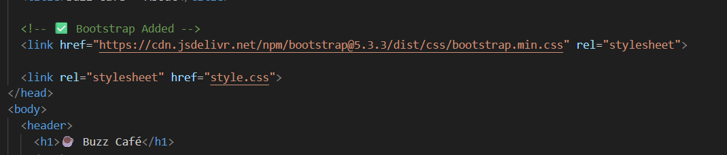

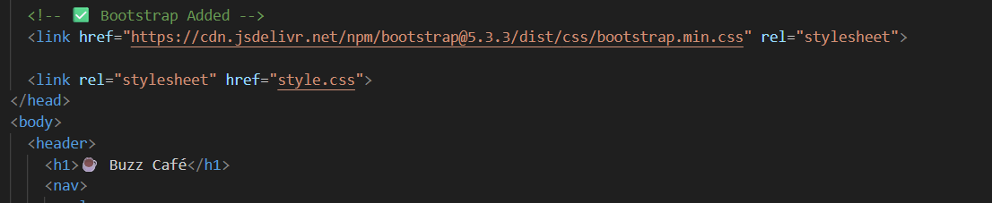

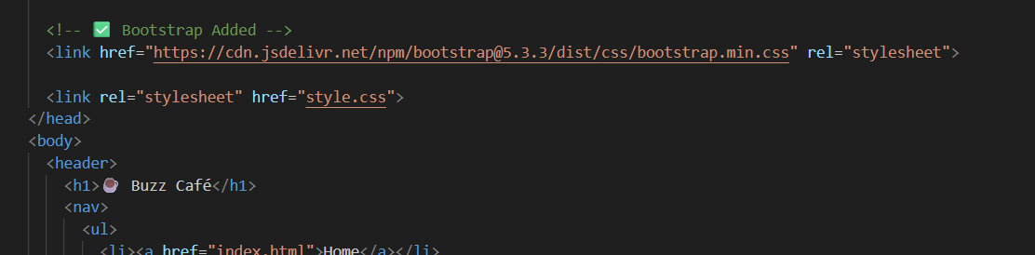

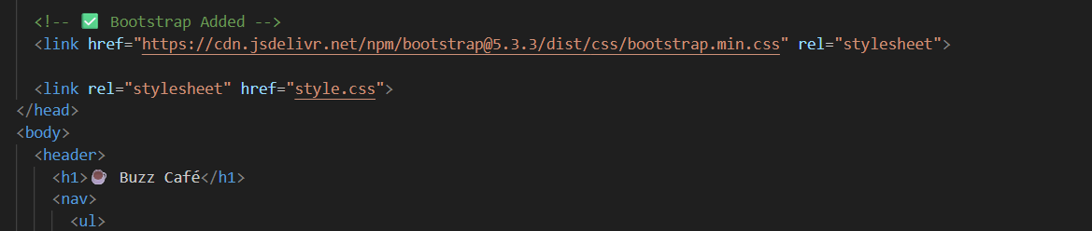

Were added to all pages!

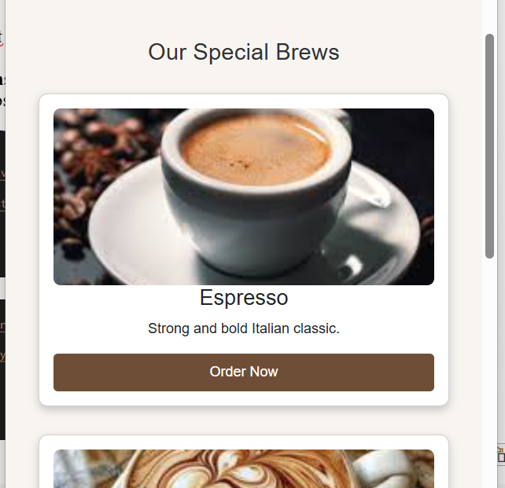

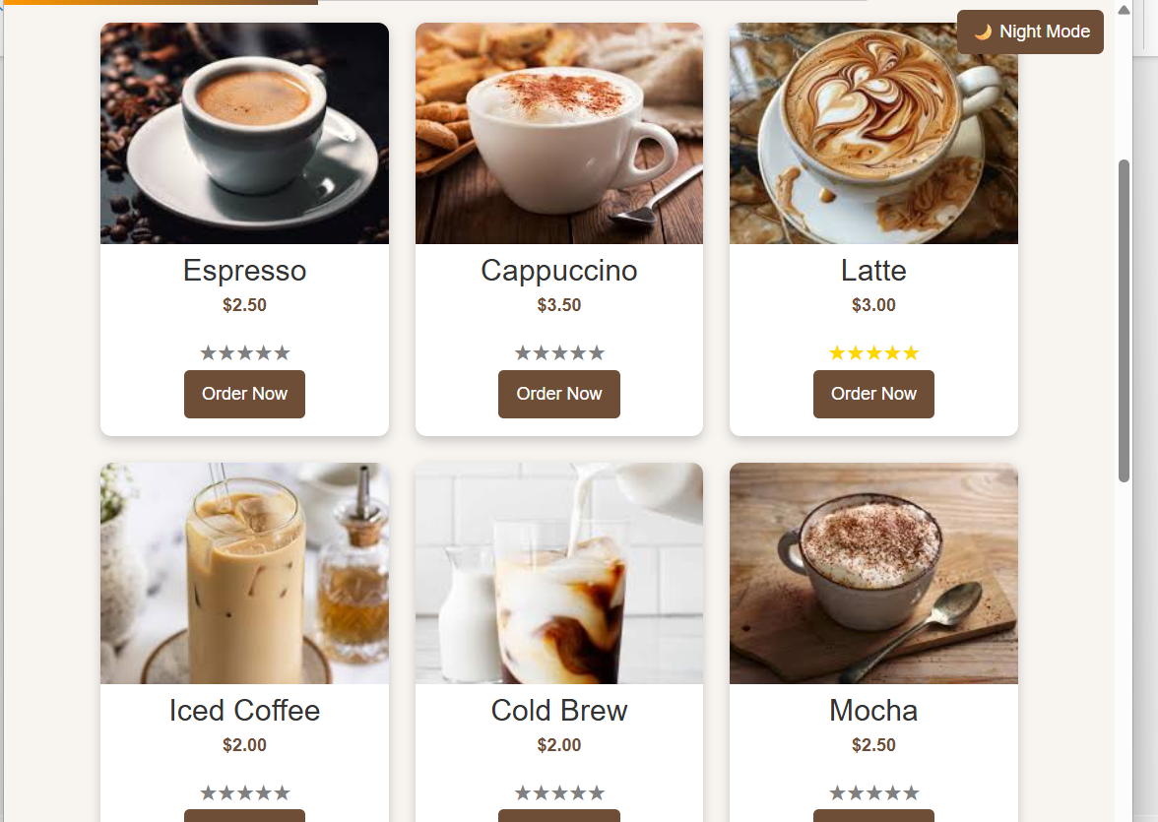
Part 2. Functional Elements and Accessibility
Task 3. Functional Buttons Only

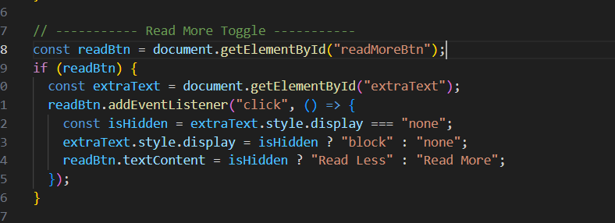

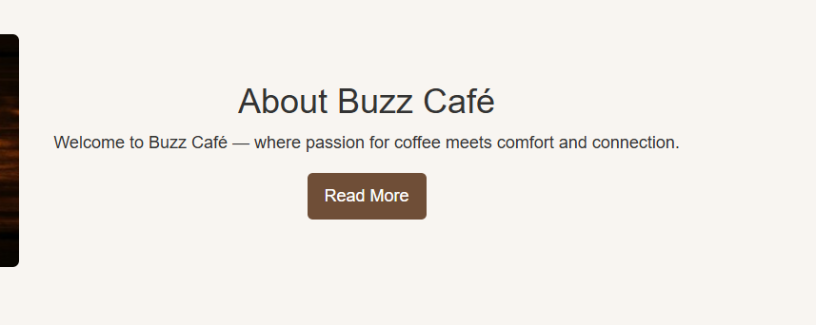

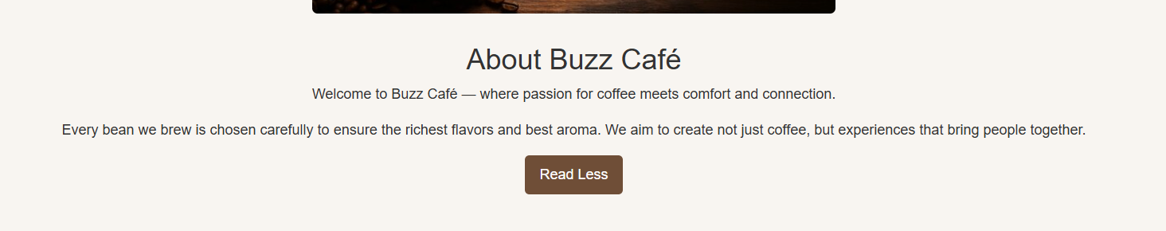

Task 4. Accessibility and Color Contrast (WCAG AA)

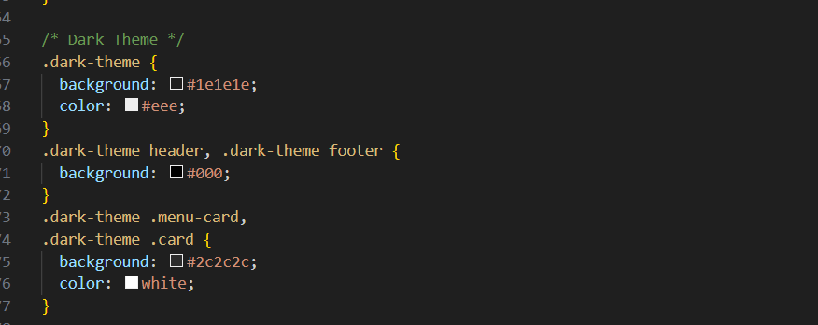

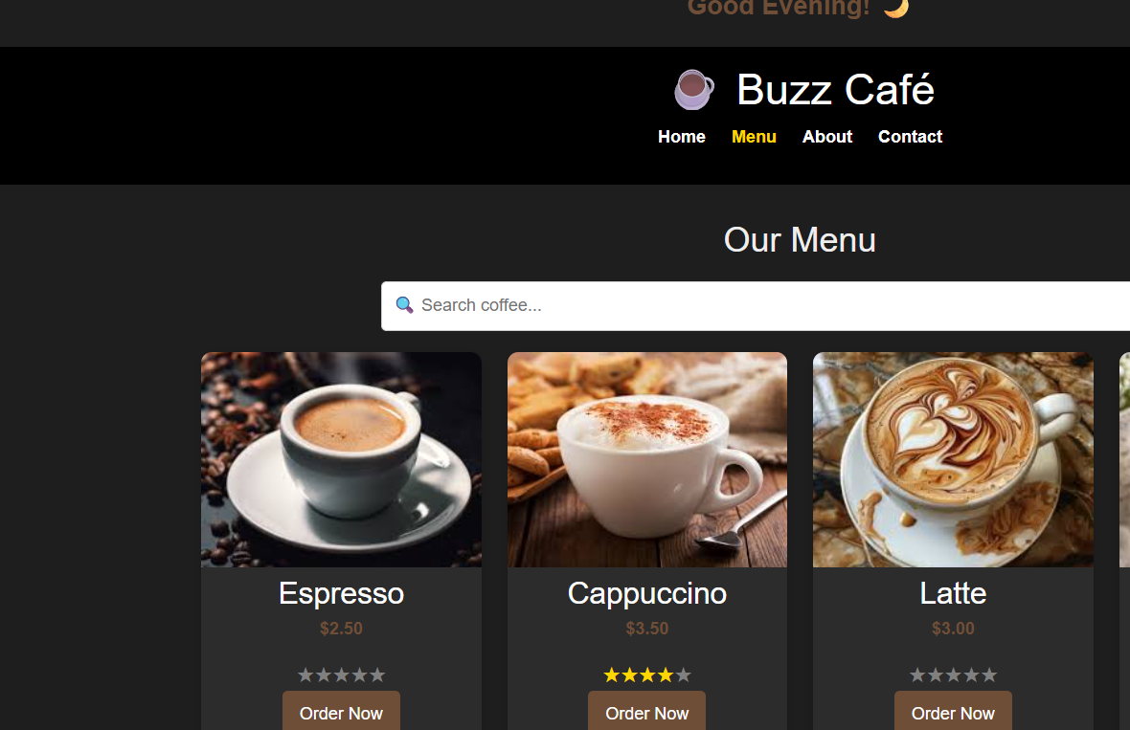

Task 5. Polished Images and Media

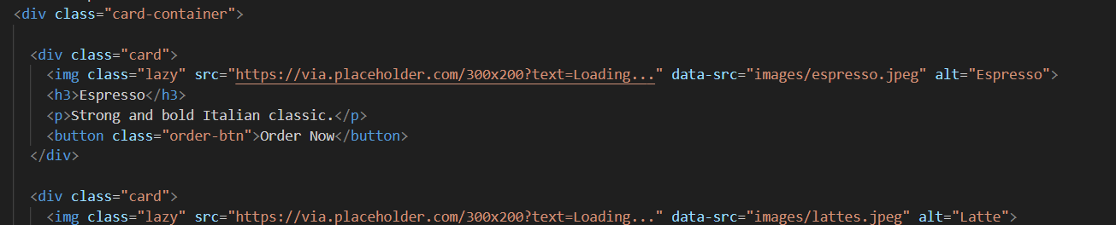

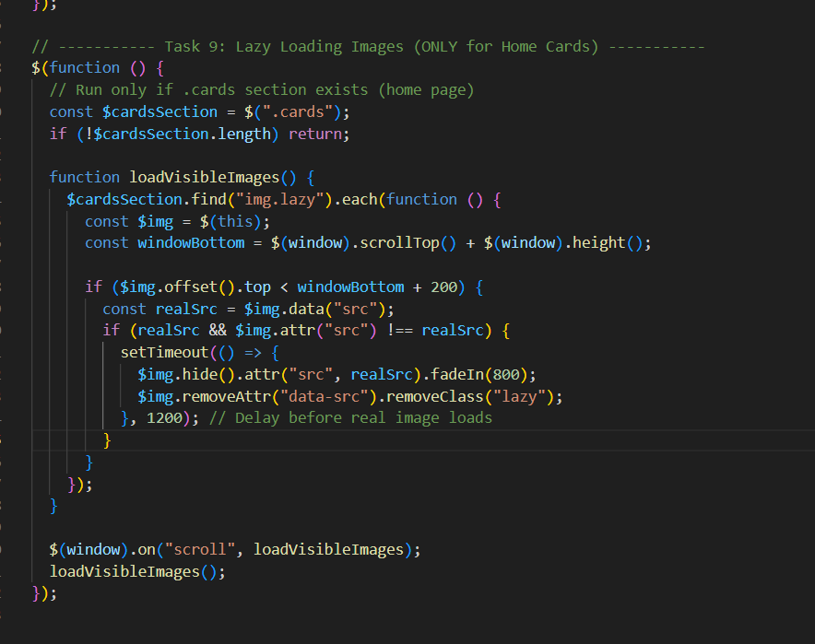

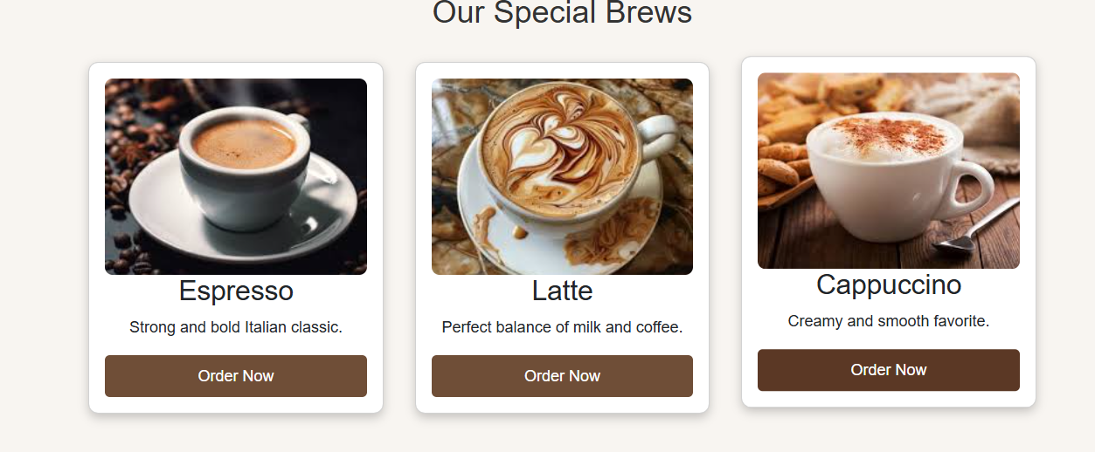

Part 3. Dark/Light Mode with Local Storage
Task 6. Day/Night Mode with Local Storage

